REFERENCES AND NOTES

1. D. R. Ort *et al*., *Proc. Natl. Acad. Sci. U.S.A.* 112, 8529–8536 (2015).

1. Z. Li, S. Wakao, B. B. Fischer, K. K. Niyogi, *Annu. Rev. Plant Biol.* 60, 239–260 (2009).
2. P. Müller, X.-P. Li, K. K. Niyogi, *Plant Physiol.* 125, 1558–1566 (2001).
3. M. L. Pérez-Bueno, M. P. Johnson, A. Zia, A. V. Ruban, P. Horton, *FEBS Lett.* 582, 1477–1482 (2008).
4. S. P. Long, S. Humphries, P. G. Falkowski, *Annu. Rev. Plant Biol.*

45, 633–662 (1994).

1. C. Werner, R. J. Ryel, O. Correia, W. Beyschlag, *Plant Cell Environ.* 24, 27–40 (2001).
2. X.-G. Zhu, D. R. Ort, J. Whitmarsh, S. P. Long, *J. Exp. Bot.* 55, 1167–1175 (2004).
3. E. H. Murchie, K. K. Niyogi, *Plant Physiol.* 155, 86–92 (2011).
4. C. D. P. Duffy, A. V. Ruban, *J. Photochem. Photobiol. B* 152

(pt. B), 215–226 (2015).

1. C. A. Wraight, A. R. Crofts, *Eur. J. Biochem.* 17, 319–327 (1970).
2. M. D. Brooks, S. Jansson, K. K. Niyogi, in *Non-Photochemical Quenching and Energy Dissipation in Plants Algae and Cyanobacteria* (Springer, 2014), vol. 40, pp. 297–314.

12. X.-P. Li *et al*., *Nature* 403, 391–395 (2000).

1. B. Demmig-Adams, *Biochim. Biophys. Acta* 1020, 1–24 (1990).
2. H. Y. Yamamoto, T. O. M. Nakayama, C. O. Chichester,

*Arch. Biochem. Biophys.* 97, 168–173 (1962).

1. S. Hubbart, O. O. Ajigboye, P. Horton, E. H. Murchie, *Plant J.* 71, 402–412 (2012).
2. X.-P. Li, A. M. Gilmore, K. K. Niyogi, *J. Biol. Chem.* 277, 33590–33597 (2002).

17. A. Zia, M. P. Johnson, A. V. Ruban, *Planta* 233, 1253–1264 (2011).

1. X.-P. Li, P. Muller-Moule, A. M. Gilmore, K. K. Niyogi, *Proc. Natl. Acad. Sci. U.S.A.* 99, 15222–15227 (2002).
2. B. Demmig-Adams, W. W. Adams III, *Planta* 198, 460–470 (1996).
3. M. Nilkens *et al*., *Biochim. Biophys. Acta* 1797, 466–475 (2010).
4. M. P. Johnson, P. A. Davison, A. V. Ruban, P. Horton, *FEBS Lett.* 582, 262–266 (2008).

22. A. V. Ruban, *Plant Physiol.* 170, 1903–1916 (2016).

1. P. Horton, A. V. Ruban, R. G. Walters, *Annu. Rev. Plant Physiol. Plant Mol. Biol.* 47, 655–684 (1996).
2. S. P. Long, X.-G. Zhu, S. L. Naidu, D. R. Ort, *Plant Cell Environ.*

29, 315–330 (2006).

1. S.-H. Chang, R. C. Bugos, W.-H. Sun, H. Y. Yamamoto,

*Photosynth. Res.* 64, 95–103 (2000).

1. W.-H. Sun, A. S. Verhoeven, R. C. Bugos, H. Y. Yamamoto,

◥

REPORTS

SOLAR CELLS

## Perovskite-perovskite tandem photovoltaics with

optimized band gaps

Giles E. Eperon,1,2* Tomas Leijtens,3* Kevin A. Bush,3 Rohit Prasanna,3 Thomas Green,1 Jacob Tse-Wei Wang,1 David P. McMeekin,1 George Volonakis,4 Rebecca L. Milot,1 Richard May,2 Axel Palmstrom,5 Daniel J. Slotcavage,3 Rebecca A. Belisle,3

Jay B. Patel,1 Elizabeth S. Parrott,1 Rebecca J. Sutton,1 Wen Ma,6 Farhad Moghadam,6 Bert Conings,1,7 Aslihan Babayigit,1,7 Hans-Gerd Boyen,7 Stacey Bent,5

Feliciano Giustino,4 Laura M. Herz,1 Michael B. Johnston,1 Michael D. McGehee,2† Henry J. Snaith1†

We demonstrate four- and two-terminal perovskite-perovskite tandem solar cells with ideally matched band gaps. We develop an infrared-absorbing 1.2–electron volt band-gap perovskite, FA0.75Cs0.25Sn0.5Pb0.5I3, that can deliver 14.8% efficiency. By combining this material with a wider–band gap FA0.83Cs0.17Pb(I0.5Br0.5)3 material, we achieve monolithic two-terminal tandem efficiencies of 17.0% with >1.65-volt open-circuit voltage. We also make mechanically stacked four-terminal tandem cells

and obtain 20.3% efficiency. Notably, we find that our infrared-absorbing perovskite cells exhibit excellent thermal and atmospheric stability, not previously achieved

for Sn-based perovskites. This device architecture and materials set will enable

“all-perovskite” thin-film solar cells to reach the highest efficiencies in the long term at the lowest costs.

# M

*Photosynth. Res.* 67, 41–50 (2001).



Downloaded from <http://science.sciencemag.org/>on May 2, 2017

1. K. K. Niyogi, A. R. Grossman, O. Björkman, *Plant Cell* 10, 1121–1134 (1998).
2. M. Havaux, L. Dall’osto, R. Bassi, *Plant Physiol.* 145, 1506–1520

(2007).

29. N. Wang *et al*., *Physiol. Plant.* 132, 384–396 (2008).

30. D. R. Ort, S. P. Long, *Science* 344, 484–485 (2014).

31. J. Kromdijk, S. P. Long, *Proc. Biol. Sci.* 283, 20152578 (2016).

32. D. Tilman, M. Clark, *Daedalus* 144, 8–23 (2015).

ACKNOWLEDGMENTS

We thank D. Drag and B. Harbaugh for plant management in greenhouse and field studies; M. Kobayashi for performing the high-performance liquid chromatography analysis of pigments from the field-grown plants; and K. Kucera, M. Steiner, and

S. Gillespie for general assistance during laboratory- and fieldwork. We also thank T. Clemente for initial help with tobacco transformation. This research was supported by Bill and Melinda Gates Foundation grant OPP1060461, titled “RIPE—Realizing increased photosynthetic efficiency for sustainable increases in crop yield.” K.K.N. is an investigator of the Howard Hughes Medical Institute and the Gordon and Betty Moore Foundation (through grant GBMF3070). The data reported in this paper have been tabulated in the supplementary materials. Plants and constructs reported are available from the University of Illinois and University of California, Berkeley, for research purposes, subject to the conditions of the Uniform Biological Material Transfer Agreement. The University of Illinois has submitted a provisional patent on behalf of J.K., K.G., L.L., K.K.N., and

S.P.L on aspects of the findings.

SUPPLEMENTARY MATERIALS

[www.sciencemag.org/content/354/6314/857/suppl/DC1](http://www.sciencemag.org/content/354/6314/857/suppl/DC1) Materials and Methods

Figs. S1 to S14 Tables S1 to S3 Data Sets 1 to 21

References (*33*–*49*)

29 August 2016; accepted 28 September 2016 10.1126/science.aai8878

etal halide perovskites [ABX3, where A is typically Cs, methylammonium (MA), or formamidinium (FA); B is Pb or Sn; and X is I, Br, or Cl] have emerged as an extremely promising photovoltaic (PV)

technology owing to their rapidly increasing power conversion efficiencies (PCEs) and low processing costs. Single-junction perovskite de- vices have reached a certified 22% PCE (*1*), but the first commercial iterations of perovskite PVs will likely be as an “add-on” to silicon (Si) PVs. In a tandem configuration, a perovskite with a band gap of ~1.75 eV can enhance the ef- ficiency of the silicon cell. (*2*) An all-perovskite tandem cell could deliver lower fabrication costs, but requires band gaps that have not yet been realized. The highest-efficiency tandem devices would require a rear cell with a band gap of 0.9 to 1.2 eV and a front cell with a band gap of 1.7 to 1.9 eV. Although materials such

1Department of Physics, University of Oxford, Clarendon Laboratory, Parks Road, Oxford OX1 3PU, UK. 2Department of Chemistry, University of Washington, Seattle, WA, USA. 3Department of Materials Science, Stanford University,

Lomita Mall, Stanford, CA, USA. 4Department of Materials, University of Oxford, Parks Road, Oxford OX1 3PH, UK.

5Department of Chemical Engineering, Stanford University,

Via Ortega, Stanford, CA, USA. 6SunPreme, Palomar Avenue, Sunnyvale, CA, USA. 7Institute for Materials Research, Hasselt University, Diepenbeek, Belgium.

*These authors contributed equally to this work. *†*Corresponding author. Email: [mmcgehee@stanford.edu](mailto:mmcgehee@stanford.edu) (M.D.M.); henry.snaith@ physics.ox.ac.uk (H.J.S.)

as FA0.83Cs0.17Pb(I*x*Br1-*x*)3 deliver appropriate band gaps for the front cell (*2*), Pb-based ma- terials cannot be tuned to below 1.48 eV for the rear cell. Completely replacing Pb with Sn can shift the band gap to ~1.3 eV (for MASnI3) (*3*), but the tin-based materials are notorious- ly air sensitive and difficult to process, and PV devices based on them have been limited to ~6% PCE. (*3*, *4*) An anomalous band-gap bowing in mixed tin-lead perovskite systems (MAPb0.5Sn0.5I3) has given band gaps of ~1.2 eV but mediocre performance (~7% PCE). Very recently, PCE of >14% has been reported with MA0.5FA0.5Pb0.75Sn0.25I3 cells, for band gaps

>1.3 eV and all-perovskite four-terminal tandem cells with 19% efficiency (*5*, *6*, *7*). Here, we dem- onstrate a stable, 14.8% efficient perovskite solar cell based on a ~1.2-eV band gap FA0.75Cs0.25Pb0.5 Sn0.5I3 absorber. We measure open-circuit vol- tages (*V*oc’s) of up to 0.83 V in these cells, which represents a smaller voltage deficit between band gap and *V*oc than measured for the highest- efficiency lead-based perovskite cells. We then combined these with 1.8-eV FA0.83Cs0.17Pb(I0.5Br0.5)3 perovskite cells, to demonstrate current-matched and efficient (17.0% PCE) monolithic all-perovskite two-terminal tandem solar cells on small areas and 13.8% PCE on large areas, with *V*oc >1.65 V. Finally, we fabricated 20.3% efficient small-area and 16.0% efficient 1-cm2 all-perovskite four- terminal tandems using a semitransparent 1.6-eV FA0.83Cs0.17Pb(I0.83Br0.17)3 front cell.

Fig. 1. Tin-lead alloying. (A) Scanning electron micrographs showing the top surface of FASn*x*Pb1-*x*I3 films with different Sn percentages and FA0.75Cs0.25Pb0.5Sn0.5I3 (“50% Sn,

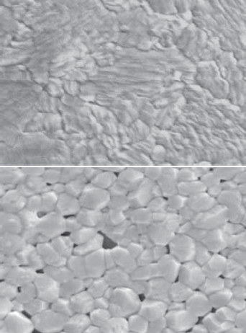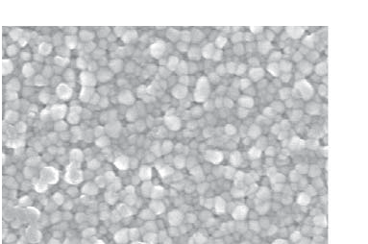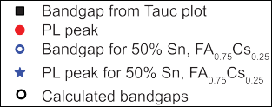

Downloaded from <http://science.sciencemag.org/>on May 2, 2017

FA0.75Cs0.25”), fabricated by PAI deposition. The 0% Sn films were annealed at 170°C, and the other films were annealed at 70°C. (B) Plot of experimentally estimated band gap as a function of Sn percentage, determined from absorption onset in a Tauc plot (assuming direct band gap) of the absorption (black); PL peak positions are given in red. (C) Band gaps for Sn-Pb perovskite alloys calculated from first principles using a supercell containing eight BX6 octahedra, where the Sn and Pb atoms are ordered relative to each other (see supplementary materials for full details). Points plotted represent all possible band gaps for a particular composition, based on all possible Sn-Pb configurations; a solid line is drawn through the lowest band-gap options as a comparison to experiment.

It has proved difficult to fabricate smooth, pinhole-free layers of tin-based perovskites on planar substrates (fig. S1) (*3*, *4*). We developed a technique, precursor-phase antisolvent immersion (PAI), to deposit uniform layers of tin-containing perovskites, FASn*x*Pb1-*x*I3, that combines two previous methods: the use of low–vapor pres- sure solvents to retard crystallization by form- ing precursor complexes and an antisolvent bath to crystallize the film with only gentle heat- ing (*4*, *8*). Rather than using neat dimethyl sul- foxide (DMSO) as a solvent (*4*), a mixture of DMSO and dimethylformamide (DMF) allowed spin- coating of a uniform transparent precursor film that was not yet fully crystallized. Immersion of the films immediately in an antisolvent bath (anisole) (fig. S2) rapidly changed the film to a deep red. (*9*) Subsequent annealing at 70°C re- moved residual DMSO (fig. S7) to form smooth, dark, highly crystalline and uniform FASn*x*Pb1-*x*I3 films over the entire range of values of *x* = 0 to 1 (Fig. 1A). Only the neat Pb perovskite required heating at a higher temperature (170°C) to con- vert the film from the yellow room-temperature phase to the black phase (*10*).

Photoluminescence (PL) spectra and absorp- tion spectra of a range of compositions (fig. S4)

Table 1. Device parameters corresponding to the *J*-*V* curves in Fig. 2B.

*J*SC

(mA cm−2)

|  |  |
| --- | --- |
|  |  |
|  |  |

allowed us to estimate the optical band gap from Tauc plots (from absorption, as discussed in the supplementary materials) and the PL peak posi- tions (Fig. 1B) (*9*). The band gap narrowed be- tween the two composition end points, similar to the observations of Kanatzidis *et al*. with the MA system (*5*), and between 50 and 75% Sn, was almost 1.2 eV. X-ray diffraction (XRD) spectra (fig. S5) for the whole series revealed a single dominant perovskite phase (table S1).

To understand this anomalous band-gap trend, we performed first-principles calculations of band gaps as a function of the tin-lead ratio (de- tails in the supplementary materials) (*9*). For a disordered solid solution with Pb and Sn in random locations, the calculated band gap de- creased monotonically (fig. S8). For an ordered structure, we placed the Sn and Pb atoms in specific positions relative to each other within a repeating lattice unit of eight octahedra in a “supercell.” Here, if we take the lowest band gaps for each ratio, an anomalous band-gap trend emerges (Fig. 1C). For compositions with >50% Sn, a specific type of short-range order in the Pb-Sn positions allowed the band gap to dip below the end points. Im *et al*. attributed a sim- ilar band-gap trend observed for MAPb*x*Sn1-*x*I3

*V*OC (V)

FF

PCE (%)

SPO (%)

to the competition between spin-orbit coupling and distortions of the lattice (*11*), but if this was the case here, we should have observed it in the random solid solution approach. The energetic difference between the various Pb-Sn config- urations was on the order of 2 meV, so at room temperature, the materials are likely to contain various combinations of the configurations that we show in fig. S7, but the absorption and emis- sion onsets reflect the regions with the smallest gap. To determine the charge-carrier diffusion length, mobility, and recombination lifetimes of these materials, we performed optical pump- probe terahertz (THz spectroscopy) on FASnI3 and FASn0.5Pb0.5I3. The fluence dependence of the THz transients for FASn0.5Pb0.5I3 (fig. S9) ex- hibited faster decays at higher intensities as the result of increased bimolecular and Auger recom- bination (*12*). We calculated recombination rate constants and charge-carrier mobilities of 22 and 17 cm2 V−1 s−1 for FASnI3 and FASn0.5Pb0.5I3, respec- tively, comparable to values for Pb perovskite films (*12*, *13*). In comparison, for MASnI3, the value was only 2 cm2 V−1 s−1 (*3*, *14*). For charge- carrier densities typical under solar illumina- tion, charge-carrier diffusion lengths of ~300 nm were obtained for FASn0.5Pb0.5I3 (details in the supplementary materials). Although lower than that for the best reported perovskite ma- terials, it is equivalent to the typical thickness required to absorb most incident light (~300 to

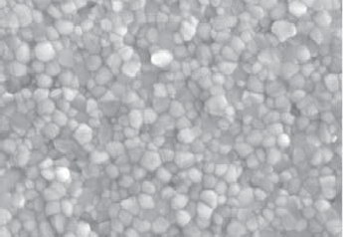400 nm) (*15*).

We fabricated a series of planar heterojunction devices in the “inverted” p-i-n architecture (*16*) comprising indium-tin-oxide (ITO)/poly(3,4- ethylenedioxythiophene)-poly(styrenesulfonate) (PEDOT:PSS)/FASn*x*Pb1-*x*I3/C60/bathocuproine (BCP) capped with an Ag or Au electrode (Fig. 2A). The current density–voltage (*J*-*V*) curves and external quantum efficiency (EQE) measurements for the whole compositional series are shown in fig. S10. The onset of the EQEs closely matched that of the absorption of the materials, with light harvested out to ~1020 nm in the 50 to 75% Sn compositions. The highest efficiencies are generated from the devices with 50% Sn, within the lowest band-gap region; thus, we used this material to optimize our low-gap solar cells.

A small addition of Cs boosts the performance and stability of Pb-based perovskites (*17*–*19*). Substituting 25% of the FA with Cs in our films had little impact on band gap, morphology, PL, crystal structure, and charge carrier diffusion lengths (Fig. 1 and figs. S4 and S7), but device performance was enhanced (Fig. 2, B to D). The best FASn0.5Pb0.5I3 device yields 10.9% PCE, whereas the best FA0.75Cs0.25Sn0.5Pb0.5I3 device exhibited an impressive short-circuit current of 26.7 mA cm−2,

0.74 V *V*oc, and 0.71 fill factor (FF) to yield 14.1% PCE. The processing of each composition was op- timized separately. These devices did not exhibit appreciable rate-dependent hysteresis, and the sta- bilized power output (14.8%) matched the scanned performance well. This efficiency was compara- ble with that of the best solution-processed low– band gap copper-indium-gallium-diselenide (CIGS) solar cells. (*20*) Thus, FA0.75Cs0.25Pb0.5Sn0.5I3 is well

F.. .A...S...n..0.....5..P..b...0....5..I..3...........................................2...1....9.............................0.....7..0......................0.....6..6.......................1..0.....2.............................1..0 9........

F.. .A...0....7..5..C.. .s..0....2..5..S...n...0....5..P.. .b...0....5..I.3.... ..2...6.....7.. 0.....7. 4 ..0.....7.. .1.. ...1..4.....1.. 1..4 8..





Fig. 2. Performance and stability of FASn0.5Pb0.5I3 and FA0.75Cs0.25Sn0.5 Pb0.5I3 perovskite solar cells. (A) Schematic of the device architecture for narrow-gap single-junction perovskite solar cells. (B) Current-voltage characteristics under AM1.5G illumination for the best FASn0.5Pb0.5I3 and FA0.75Cs0.25Sn0.5Pb0.5I3 devices under illumination (solid lines) and in the dark (dashed lines), mea- sured at 0.1 V/s with no prebiasing or light soaking. (C) Stabilized power output for the best solar cells, measured via a maximum power point tracking

algorithm. (D) External quantum efficiency for the best devices of each material with the integrated current values shown providing a good match to the *J-V* scan *J*sc. (E) PCE as a function of time for three compositions of FASn*x*Pb1-*x*I3 (*x* = 0, 0.5, 1) as well as FA0.75Cs0.25Sn0.5Pb0.5I3, measured by holding the cell at maximum power point in air under AM1.5G illumination. (F) Thermal stability of FASn0.5Pb0.5I3 and FA0.75Cs0.25Sn0.5Pb0.5I3 films, quantified by heating the sam- ples at 100°C and monitoring their absorption at 900 nm as a function of time.





|  |  |  |
| --- | --- | --- |
|  |  |  |
|  |
|  |
|  |
|  |
|  |

Fig. 3. Perovskite-perovskite tandems. (A) Schematics showing 2T and 4T tandem perovskite solar cell concepts. In this image, devices would be illu- minated from below. (B) Scanning electron micrograph of the 2T perovskite- perovskite tandem. (C) Scanned current-voltage characteristics under AM 1.5G illumination, of the two-terminal perovskite-perovskite tandem, the 1.2-eV solar cell, and the ITO-capped 1.8-eV solar cell. (D) External quantum efficiency spectra for the subcells. (E) *J*-*V* curves of a 1.2-eV perovskite, of the same solar cell filtered by an ITO-capped 1.6-eV perovskite solar cell, and of the ITO-capped

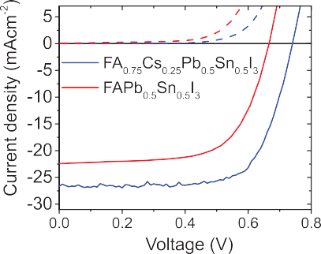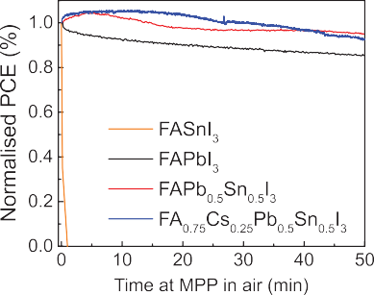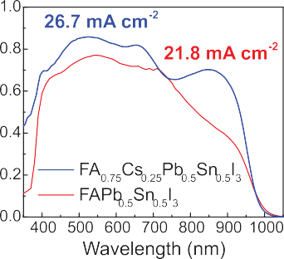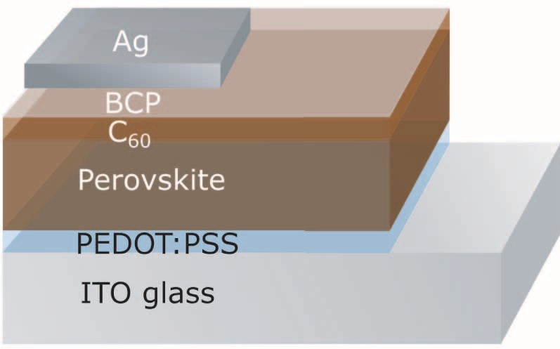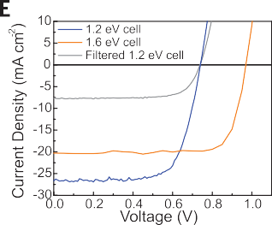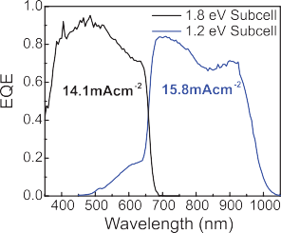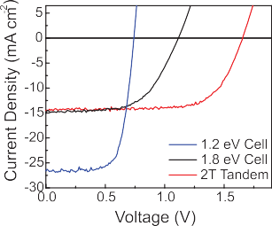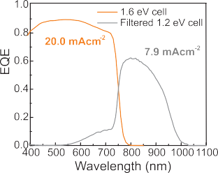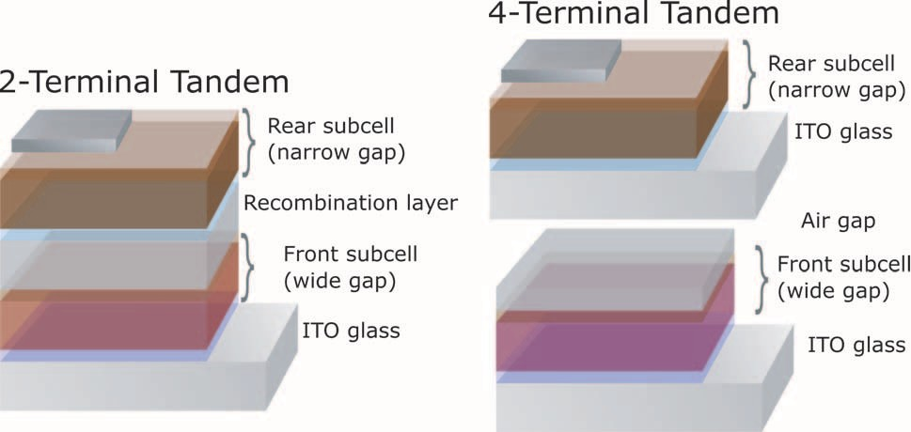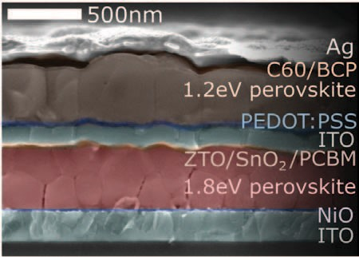

Downloaded from <http://science.sciencemag.org/>on May 2, 2017

1.6-eV perovskite solar cell, used to determine the mechanically stacked tan- dem efficiency. (F) External quantum efficiency spectra for the mechanically stacked tandem. (G) The stabilized power output tracked over time at max- imum power point for the 2T perovskite solar cell, the 1.2-eV perovskite solar cell filtered by an ITO-capped 1.6-eV perovskite solar cell, the ITO-capped 1.6-eV perovskite solar cell, and the mechanically stacked tandem under AM1.5G illumination. The stabilized power output (SPO) for the 1.8-eV subcell is plotted in fig. S14 and given in Table 2.

Table 2. Solar cell performance parameters corresponding to the *J*-*V* curves shown in Fig. 3. Cell active areas are 0.20 or 1 cm2. SPO, stabilized power output from maximum power point tracking. Large-area tandem data are plotted in fig. S19.

FA0.75Cs0.25Sn0.5Pb0.5I3 solar cell directly on top. We plot the *J-V* curves of the best single- junction 1.2-eV cells and single-junction 1.8-eV cell, and that of the best 2T tandem device, in Fig. 3C. We observed good performance for the 2T tandem solar cells, exceeding either of the

*J*SC

(mA cm−2)

*V*OC

1. FF PCE (%) SPO (%)

individual subcells despite the somewhat non- optimized 1.8-eV top cell. The photocurrent of

1.. ...2..-..e..V....c...e..l.l..................................................2...6.....7.............................0....7...4......................0.....7..1.........................1..4.....1.............................1.4 8........

1.. ...8...-.e..V....c...e..l.l...................................................1..5.. ...1.............................1....1..2.......................0.....5...8..........................9.....8..............................9 5........

2.. .T....t..a...n..d...e...m...................................................1..4.. ...5.............................1....6...6......................0.....7..0.........................1..6.....9.............................1..7 0........

.....................................................................................................................................................................................................................

F.. .i.l.t..e...r.e...d....1....2.. .-..e..V....c..e.. .l.l....................................7....9............................0.....7..4.......................0.....7..3...........................4....4...............................4 5........

I..T..O... .-..c..a..p...p...e...d....1....6...-.e..V....c...e..l.l........................2...0.....3............................0.....9...7......................0.....7..9.........................1..5.....7............................1..5 8........

4.. .T.....t.a...n..d...e...m.....................................................–....................................–............................–...........................2...0.....1............................2..0 3........

.....................................................................................................................................................................................................................

|  |  |  |  |  |  |
| --- | --- | --- | --- | --- | --- |
| 1-cm2 2T tandem | 13.5 | 1.76 | 0.56 | 13.3 | 13.8 |
| 1-cm2 4T tandem | – | – | – | 16.4 | 16.0 |

.....................................................................................................................................................................................................................

.......... .................. .. ........... ........

the tandem solar cell was 14.5 mA cm−2; voltage is an appropriate addition of the two subcells (1.66 V); and the fill factor is 0.70, yielding an overall performance of 16.9% via a scanned *J-V* curve and of 17.0% when stabilized at its max- imum power point. None of the devices exhibit substantial hysteresis in the *J-V* curves (Fig. 3G and fig. S17).

The photocurrent is notably high when com- pared to the photocurrent density of the best reported monolithic perovskite-silicon tandems (*30*, *31*). External quantum efficiency (EQE) mea- surements (Fig. 3D) demonstrate that the two subcells are fairly well matched, with the wide-

suited for a rear junction in a solution-processed tandem solar cell, without the need for high- temperature thermal processing.



Downloaded from <http://science.sciencemag.org/>on May 2, 2017

We performed ultraviolet photoelectron spec- troscopy (UPS) and x-ray photoelectron spec- troscopy (XPS) measurements to determine the energetic positions of the conduction and valence bands (fig. S11). The band levels for FASn0.5Pb0.5I3 are well matched for C60 and PEDOT:PSS as electron and hole acceptors. The Cs-containing material showed an energetically shallower val- ance band and mild p-type doping (*21*, *22*).

The electronic losses in a solar cell are reflected by the difference in energy between the band gap of the absorber and *V*oc (the loss in potential) (*23*). For crystalline silicon PV cells, which gen- erate a record *V*oc of 0.74 V and have a band gap of 1.12 eV, this loss is 0.38 V (*24*). Some of our FA0.75Cs0.25Sn0.5Pb0.5I3 devices, with a thinner active layer, displayed *V*oc’s up to 0.83 V (fig. S11), with a 1.24-eV band gap, exhibiting a comparable loss in potential of 0.41 eV.

Tin-based perovskites have previously been ob- served to be extremely unstable in air (*25*), so we carried out a simple aging test on the FASn0.5Pb0.5I3 and FA0.75Cs0.25Pb0.5Sn0.5I3 devices, comparing to FASnI3 and FAPbI3. We held the devices at maximum power point under 100 mW cm−2 il- lumination and measured power output over time in ambient air with a relative humidity of 50 ± 5% (Fig. 2E). The FAPbI3 device maintained its performance relatively well, with a small drop observed over the time (to 85% of initial PCE over 50 min), possibly associated with photo- oxidation and hydration of the unencapsulated perovskite layer, or a partial reversion to the yellow room-temperature phase (*17*, *26*). Both the FASn0.5Pb0.5I3 and FA0.75Cs0.25Sn0.5Pb0.5I3

showed a stability similar to or even better than

the neat Pb material. We also subjected bare pe- rovskite films to thermal stress, heating for 4 days at 100°C under nitrogen; there were no changes in absorption spectra, a monitor of optical quality and hence stability (Fig. 2F) (*27*). We also mon- itored the performance of full devices at 85°C over

several months (fig. S13) and found that the Sn:Pb material displays device stability similar to that of the neat Pb material. The contribution of both Sn and Pb orbitals to the valence band mini- mum may reduce the propensity of Sn2+ to oxidize to Sn4+.

A 1.2-eV perovskite is ideally suited as the rear cell in either monolithic two-terminal (2T) tan- dem solar cells or mechanically stacked four- terminal (4T) tandem solar cells (Fig. 3A). The subcells in a 2T tandem must be current matched to deliver optimum performance, and connected with a recombination layer. A 4T tandem operates the two cells independently but requires an extra transparent electrode, which can result in more absorption losses and higher cost. Theoretical efficiencies using a 1.2-eV rear cell (fig. S14) show that the 2T architecture requires the use of a top cell with a ~1.75- to 1.85-eV band gap, whereas the 4T architecture has a much more relaxed re- quirement of 1.6 to 1.9 eV.

We can obtain efficient and stable perovskites with appropriate wide band gaps for front cells in tandem architectures by using a mixture of FA and Cs cations (*2*) and control the band gap by tuning the Br:I ratio; FA0.83Cs0.17Pb(I0.5Br0.5)3 hasa 1.8-eV band gap that is ideally suited for the 2T tandem. However, their higher losses in potential compared with the more commonly used 1.6-eV perovskites (*28*) make the latter better suited for the 4T tandem. We prepared both of these perovskites in the p-i-n structure depicted in Fig. 3A, using NiO*x* and phenyl-C61- butyric acid methyl ester (PCBM) as the hole and electron contacts, respectively. We applied PAI deposition to form smooth and thick perovskite layers, obtaining efficient devices with appro- priate photocurrents and voltages up to 1.1 V (see fig. S14) (*9*).

For the recombination layer in the 2T cell, we used layers of tin oxide and zinc-tin-oxide (ZTO) coated with sputter-coated ITO (*29*). This ITO layer completely protects the underlying perov- skite solar cell from any solvent damage (fig. S16), meaning that we could fabricate the 1.2-eV

gap subcell limiting the current. One benefit of a tandem architecture, which we observe here, is that the FF tends not to be limited to the lowest value of the individual subcells, owing to the reduced impact of series resistance on a higher-voltage cell (*32*). Furthermore, we held a 2T tandem at its maximum power point under illumination in nitrogen for more than 18 hours, and it showed effectively no performance drop (fig. S18).

For a 4T tandem, we used an efficient 1.6-eV band gap FA0.83Cs0.17Pb(I0.83Br0.17)3 perovskite, similar to that reported by McMeekin *et al*. but in p-i-n configuration (*2*) with a transparent ITO top contact. We obtained a 15.8% efficient solar cell with a *V*oc ~1 V, and when we use it to filter a 14.8% FA0.75Cs0.25Sn0.5Pb0.5I3 cell, we can still extract substantial photocurrent (7.9 mA cm−2) from the low–band gap device. We plot the *J-V* curves and EQE spectra of the 1.6- and 1.2-eV cells in the 4T tandem in Fig. 3, E and F, and obtain an additional 4.5% PCE from the 1.2-eV rear cell, yielding an overall stabilized tandem efficiency of 20.3% (Fig. 3G).

The above results were for 0.2-cm2 devices. We also made large-area (1 cm2) versions of the single junctions and 2T and 4T tandems. The current- voltage characteristics of these devices are shown in Table 2 and fig. S18, with 2T tandem 1-cm2 devices exhibiting 13.8% stabilized PCE and 4T tandems 16.0%. The 17.0% PCE 2T and 20.3% 4T tandems, which are for devices that could be fur- ther optimized, already far exceed the best tan- dem solar cells made with other similarly low-cost semiconductors, such as those made with organ- ic small molecules (world record is 13%) or amor- phous and microcrystalline silicon (13.5%) (*1*, *24*). Notably, our results illustrate that the tandem cell should be at least 4 to 5% more efficient than the best 1.6-eV single-junction perovskite cells, indicating that as the efficiency of the single- junction cells increases, then the tandem approach will enable this low temperature–processed poly- crystalline thin-film technology to surpass the 30% efficiency barrier.